Documentation for the Kansas City Database

Name: Shushil Girish

002817666

**Missing Values**: 'CATEGORY2' and 'CATEGORY3' have NaN (Not a Number) values in some rows.

**Date and Time Formats**: The ‘CLOSED DATE’,'CREATION DATE' and 'CREATION TIME' columns have dates and times in a specific format. Any inconsistencies in these formats across the dataset could cause issues.

**Duplicates**: There is a duplicate field. For example, ‘DAY TO CLOSE ‘field which can be derived from the 2 fields ‘CREATION DATE ‘AND ‘CLOSED DATE’ itself.

**Inconsistent Categorization**: The columns 'CATEGORY1', 'CATEGORY2', and 'CATEGORY3' may have inconsistencies in how the data is categorized.

**Special Characters**: There could be special or non-standard characters in text fields that need identification.

**Data Conversions**: Converting fields like 'ZIP CODE' from numerical to text (if necessary), or handling any improper data types

**Alteryx:**

Data Validations:

**Business questions to build visualization.**

1. **Service Requests Over Time:**  
   • What is the overall trend in Service Requests over the years 2018-2021?  
   • How have Service Requests changed on a monthly basis?

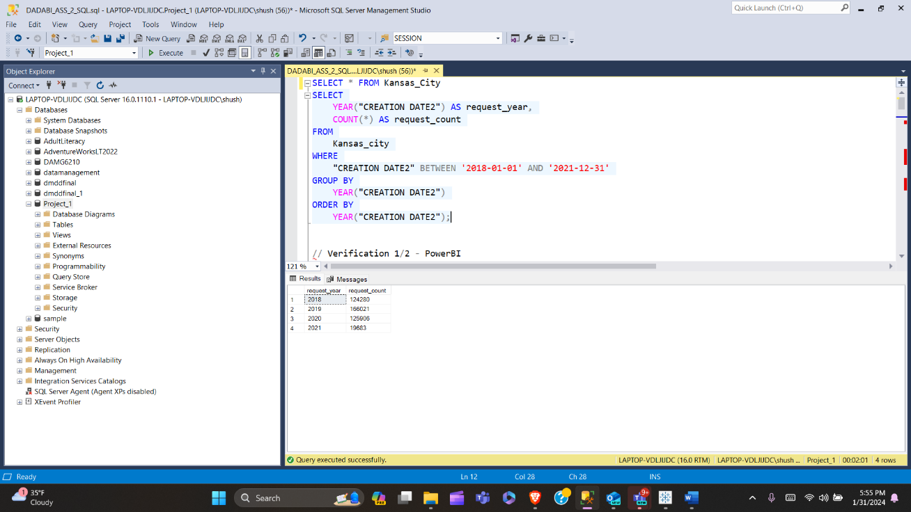

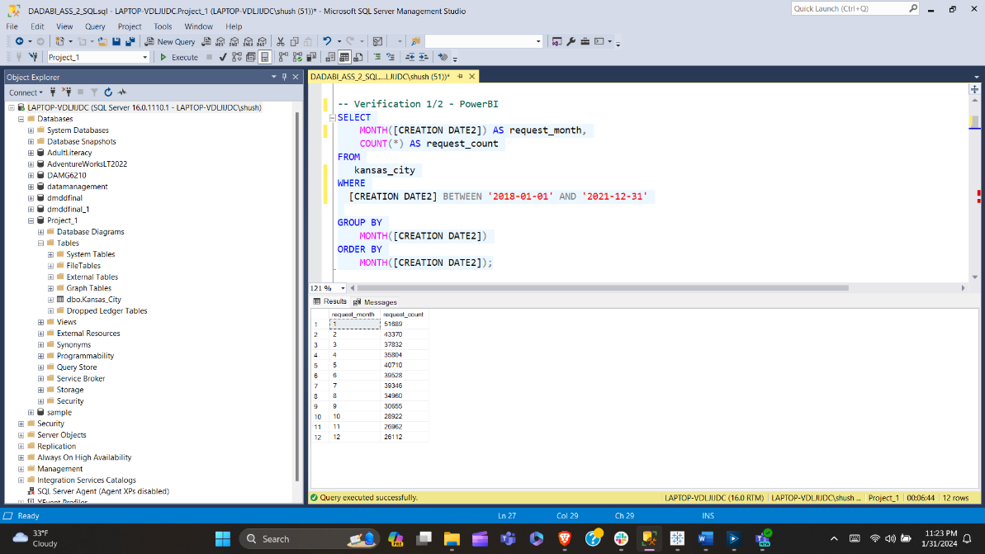

**(2) Volume of service requests received from different sources:**

• What is the overall trend in Service Requests over Sources?

**(3) Volume of service requests received by Department:**

• What is the overall trend in Service Requests received by Departments?

**(4) Top 10 Performance Metrics (Response Time) per CATEGORY and Type of Request:**

• What are the top 10 cases whose response time was fastest? Categorize it with Category1 and Type of Request.

**(5) Geographical Visualization:**

• What are the Top 10 areas where most number of request were raised?

**(6) Departmental Workload Comparison:**

• How does the workload vary among different departments and work groups? Create a visual representation to highlight the distribution.

• Hint: Generate a stacked bar chart or tree map to illustrate the distribution of service requests among different departments and work groups. This can help identify which departments are handling a larger share of the workload.

**(7) Response Time Analysis:**

• Visualize the distribution of response times for each department. Are there any outliers or patterns in response times?

**(8) Service Request Status Composition:**

• Create a visualization to show the composition of service request statuses (open, closed, in progress). How has this composition changed over the years 2018-2021?

**(9) Time to Closure Analysis:**

• Visualize the average days to close service requests for each category1. Are there categories with consistently longer closure times?

• Show top 10 (If you need help on how to restrict top 10 contact us and we can guide / help you)

**(10) Workload Efficiency:**

• Create a visualization to show the relationship between workload (number of service requests) and efficiency (days to close) for each department?

